**Milestone 2**

**SW Engineering CSC 648 - 848 Spring 2023**

**Food Delivery Application**

**GatorBites**

**Team 02**

Team Lead: Dylan Burns ([dburns6@sfsu.edu](mailto:dburns6@sfsu.edu))

Github Master/Back End: Christian Jackson

Front End Lead: Tim Polich

Back End Lead: Kevin Aziz

Front End: Wallace Man

Back End: Jeremiah Ruvalcaba

| **Date Submitted** | **Date Revised** |
| --- | --- |
| 04/01/2023 |  |
|  |  |
|  |  |

Table of Contents

1 Executive Summary……………………………………………………………………....3

2 Data Items & Entities…………………………………………………………………….4

3 Functional Requirements………………………………………………………………...9

4 UI Storyboards………………………………..…………………………………………10

5 High-Level Architecture……...……………….………………………………………....11

6 Key Risks……………………………….……………………………………………..…11

7 Project Management.…………………....………………………………………………12

**1 Executive Summary**

Introducing GatorBites - the ultimate food delivery app designed exclusively for the hungry and busy SFSU students, staff, and faculty. Our goal is simple - to provide a hassle-free experience for students and staff by delivering delicious food right to their classrooms.

We understand that time is of the essence and that's why we've leveraged our specialized knowledge of the SFSU campus, leading to a whopping 25% reduction in delivery times. Say goodbye to cold food and frustration, as our in-app navigation tool provides our drivers with real-time routing directly to your classroom of choice.

We take pride in our team of active students who work part-time to pay for their college education. These students are familiar with the campus, making food delivery an absolute breeze. However, we understand that not all our drivers may be familiar with the campus, which is why we have a stringent sign-on screening process to ensure they know their way around before joining our team.

At GatorBites, we make food delivery easy. With just four simple steps - create an account, add a payment method, enter your delivery location, and order your food - you can have your favorite meals delivered to you in no time.

Whether you're having a busy day and forgot to bring lunch to campus, need a coffee to power through your late-night classes, or just craving a cheesy pizza for a group study session, GatorBites has got you covered. We know that students and faculty are always on the move, constantly working and planning, and often forget to eat at regular intervals. With GatorBites, you can focus on what really matters, while we take care of your food delivery needs.

Join us today and experience the ultimate food delivaery service designed exclusively for SFSU students and staff - GatorBites!

**2 Data Items & Entities**

Restaurant : PK - Main

The restaurant will have a user id that will be the primary key for finding a restaurant in the database. All restaurants will have a category of food they serve. In addition, names, emails, and phone numbers will be stored. The address will be used for the delivery.

Customer : PK - Main

The customer entity will have a customer id that will be used to find the customers in the database and connect drivers to customers for delivery.

Driver : PK - Main

The driver will have a driver id that will be used to find the driver in the database to connect a driver to a customer on a delivery. Names, Vehicle info, and phone number will be stored in the database

Restaurant Owner : PK - main

The driver will have a driver id that is used to find the driver in the database to connect a driver to a customer on delivery. Names, Vehicle info, and phone numbers will be stored in the database

Menu : PK & FK - main

The Menu for a restaurant will have its own id that will be used to find the menu at a particular restaurant. A menu shall be at least at one restaurant and will have a category of food for the menu.

Delivery : PK & FK - main

The delivery will have its own id that will be used to find out where a certain delivery will be taking place.

Order: PK & FK - main

The order will have its own id that will be used to track orders from a restaurant that will be attached to a driver that is out on a delivery.

Sub entities: The following are believed sub entities of our design in addition these entities will carry unique id to identify sub entities in the database.

Menu item:

Menu items will be a part of the menu at a restaurant and will describe the type of food the customer will order which will include the price and image of a particular item. In addition, certain menu items could be offered a promotion depending on the popularity of an item.

Category:

Restaurants and Menu items will have different category types. There are many types of food. Categories will help filter out what types of food a customer could possibly order.

Complaint:

Restaurants and drivers will be able to receive complaints which will be sent by customers that will be in the form of an integer value ranging from 1-5. An admin shall review complaints that are made to Restaurants and drivers.

Promotion:

Restaurants and customers will be able to receive and send promotions. Furthermore, A Promotion shall be at one to many restaurants with a Promotion can be used by one to many customers.

Notification:

Notifications shall be sent to many users. In addition, A notification shall be sent to one to many restaurants letting them know of a and order for pickup

**3 Functional Requirements (Prioritized)**

**Priority 1** = Must Have

**Priority 2** = Desired

**Priority 3** = Opportunistic

**Priority 1**

Unregistered Users

1.1 Unregistered users shall be able to access and browse the web page.

1.2 Unregistered users shall be able to add, remove, and modify any  
 selected items that are placed inside their checkout cart.

1.3 Unregistered users shall be able to freely search for a particular item or  
 Restaurant.

SFSU Registered Users

1.1 Registered users shall be able to login.

1.2 Registered users shall be able to read their own account information.

1.3 Registered user shall be able to update their own account information

1.4 Registered users shall be able to delete their own account information.

1.5 Registered users shall be able to access their payment method an  
 account settings at any point while on the web page.

1.6 Registered users shall be able to inherit all related functions of the  
 unregistered user.

1.7 Registered users shall be able to order.

Admin

1.1 Admin shall be able to create their own account.

1.2 Admin shall be able to input account information.

1.3 Admin shall be able to read their own account information.

1.4 Admin shall be able to update their own account information

1.5 Admin shall be able to remove users or restaurants.

1.6 Admin shall be required to approve restaurant registration

1.7 Admin shall be required to approve the restaurant application.

**Priority 2**

Unregistered Users

2.1 Unregistered users shall be able to freely sign up for an account at any  
 point while accessing the page.

2.2 Unregistered users shall be able to filter out information with regards to  
 their search such as whether alcohol is being served or if the star rating  
 is above or below a certain threshold.

SFSU Registered Users

2.1 Registered users shall be able to observe their transaction history of  
 previously ordered items.

2.2 Registered users shall be able to write a review or a star rating based  
 on food quality.

2.3 Registered Users shall be able to upvote reviews pertaining to a restaurant.

2.4 Registered Users shall be able to downvote reviews pertaining to a   
 restaurant.

Admin

2.1 Admin shall be able to access the restaurant's transaction history.

**Priority 3**

Unregistered Users

3.1 Unregistered users shall be able to access reviews on a  
 restaurant based on the star customer ratings.

3.2 Unregistered users shall be able to report bugs.

SFSU Registered Users

3.1 Registered users shall receive bonus or star points that add up every  
 order that can be used to provide food at a discounted rate.

3.2 Registered users shall be able to provide a note in the system for the  
 restaurant to read before they prepare the order.

3.3 Registered users shall be able to customize the color theme of their  
 web page.

3.4 Registered users shall be able to report bugs.

Admin

3.1 Admin shall be able to access and review user feedback.

**4 UI Storyboards**

**Ordering without account**

1. Max has to finish his project by midnight and the only way he can do that is if he orders his dinner to his door. He heard about GatorBites from his roommates so he decided to give it a try. He opens the GatorBites website and **searches** what he wants into the search bar**(a)**. He is then greeted with a list of restaurants that specializes in the cuisine that he is craving**(b)**. He clicks on a restaurant that catches his eye and adds his favorite menu items to the cart**(c)**. Before he can checkout, he is greeted with the login page**(d)**. Since he is an unregistered user, he has to **register** using the sign up page**(e)**. He also gets student-only discounts because he registered with a SFSU email. He is then able to enter his information and his GatorPass to pay for the food. He also has to enter the building that he is currently residing in and the floor he is on**(f)**. 20 to 30 minutes later, the delivery driver shows up at his door.

**(a)**

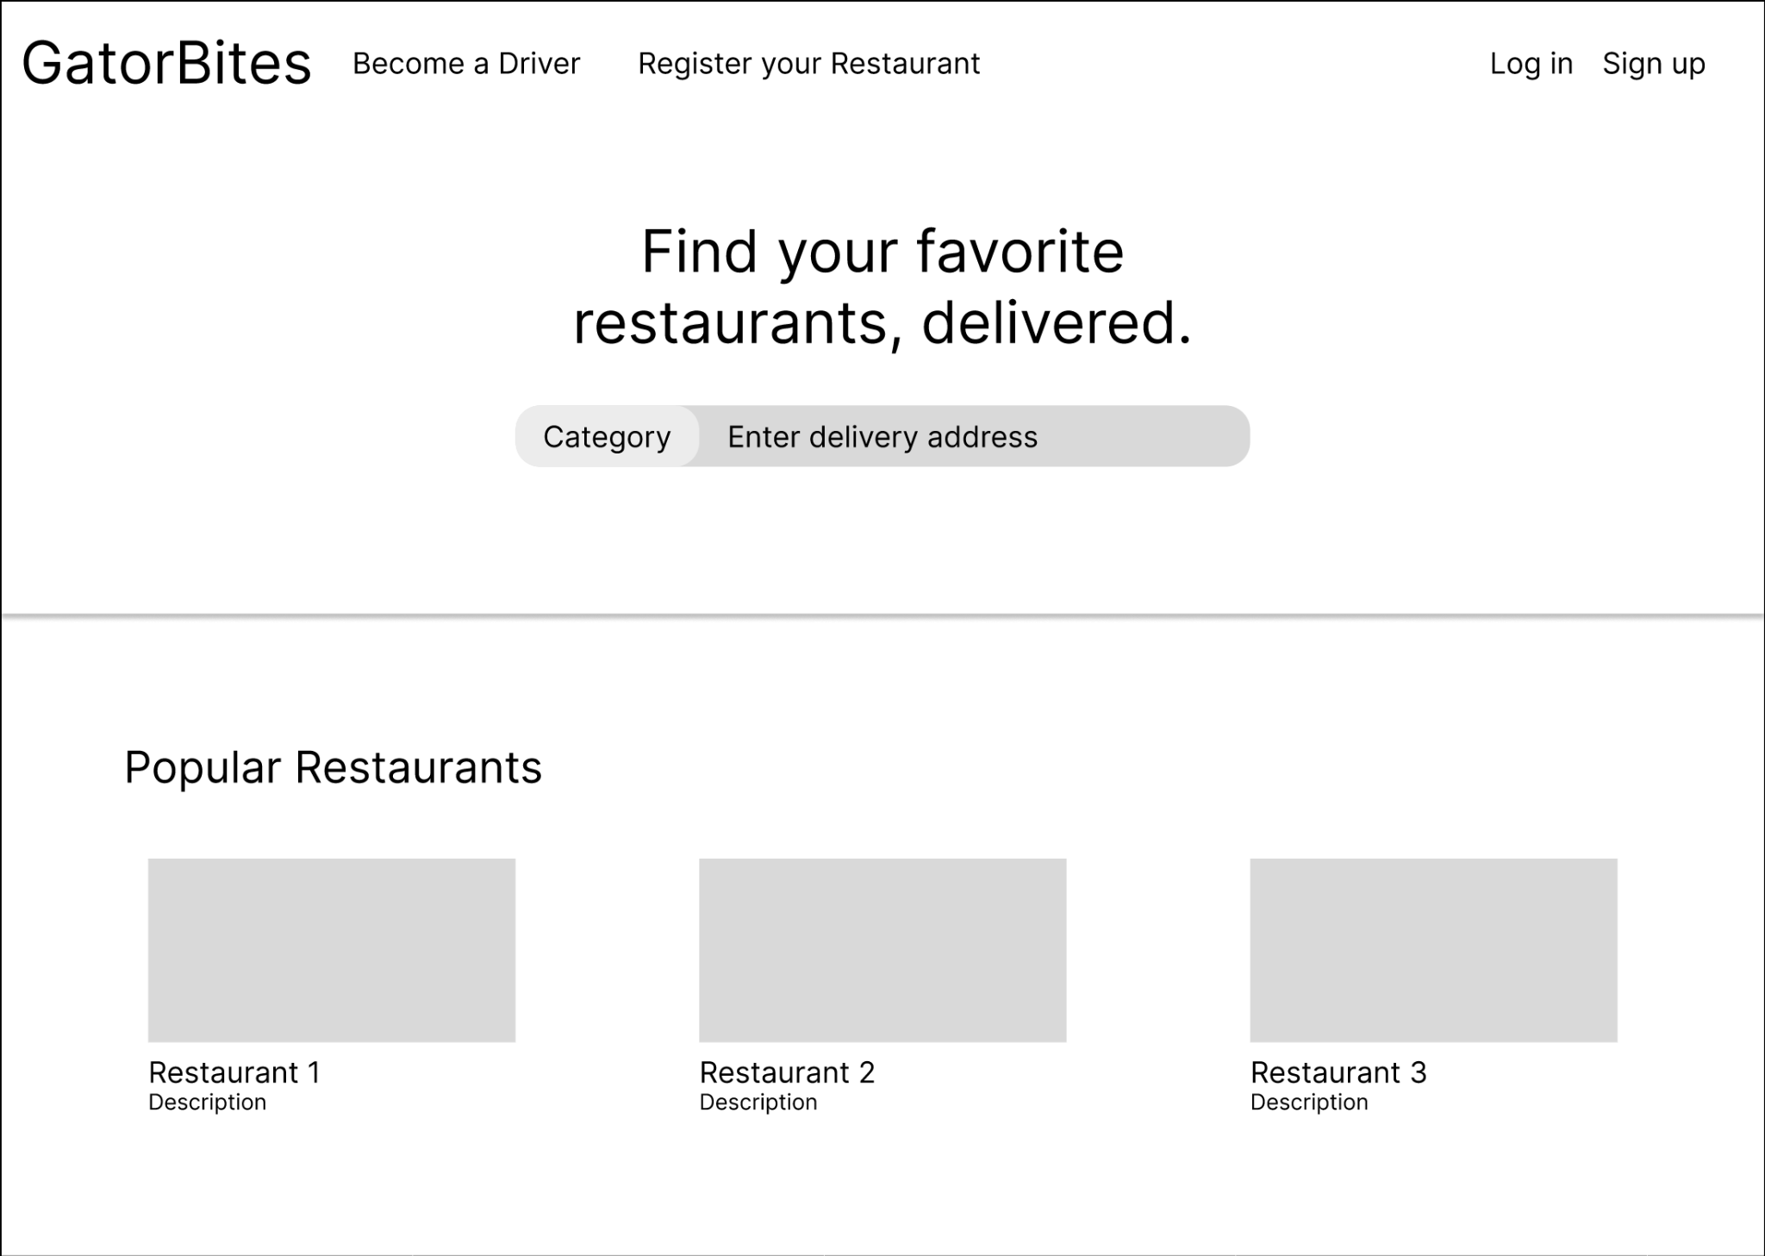

**(b)**

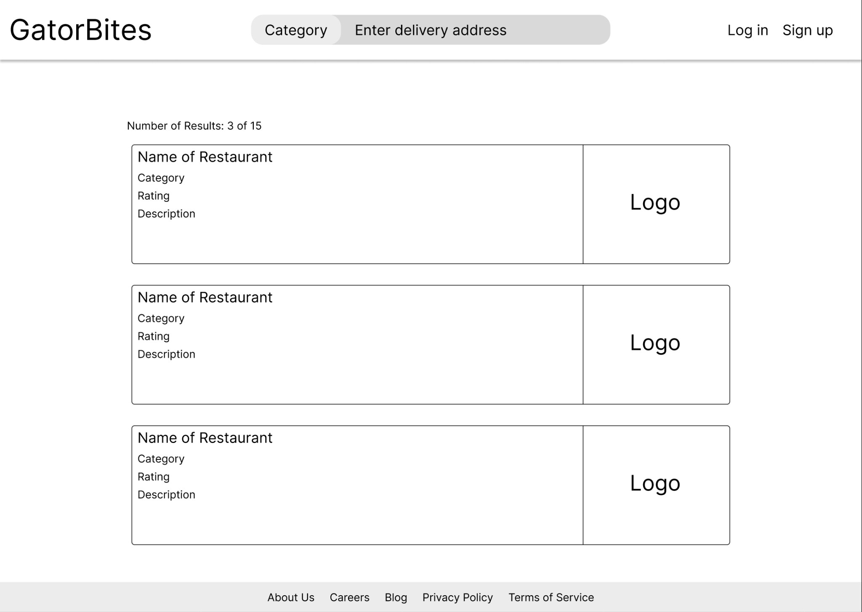

**(c)**

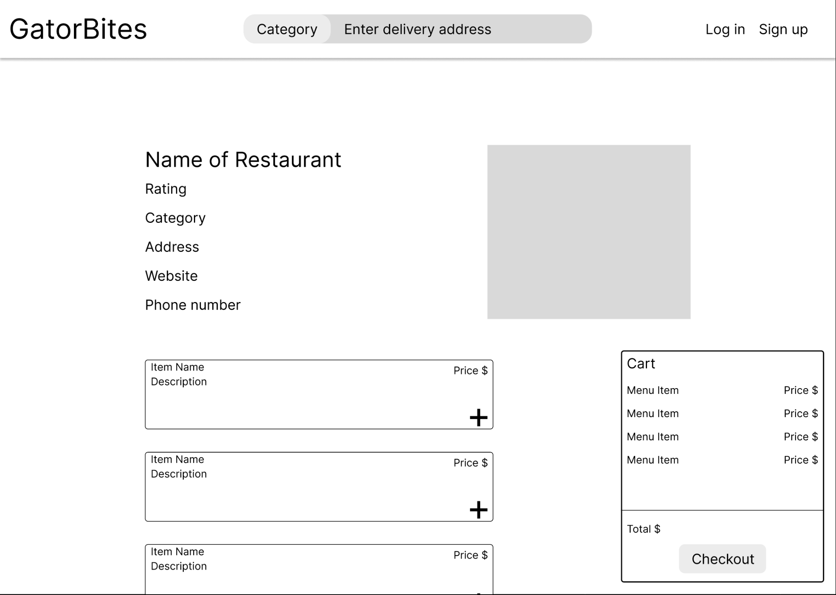

**(d)**

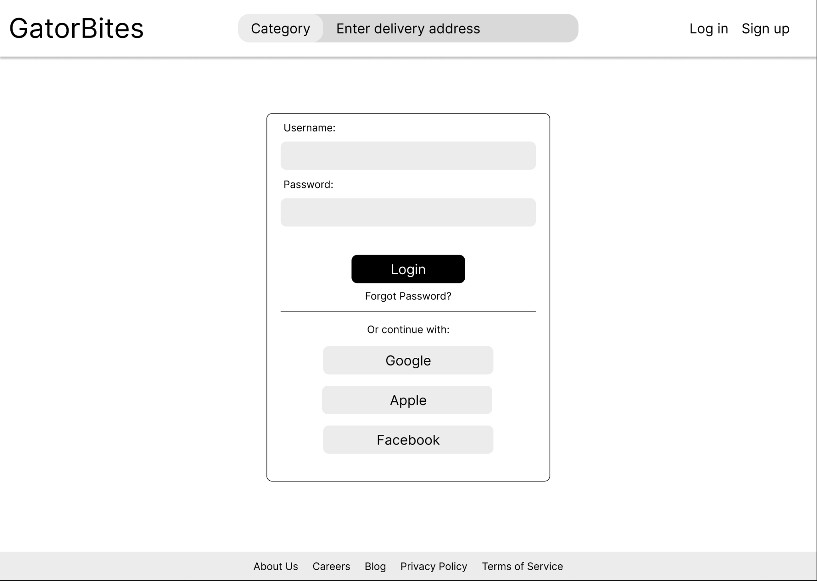

**(e)**

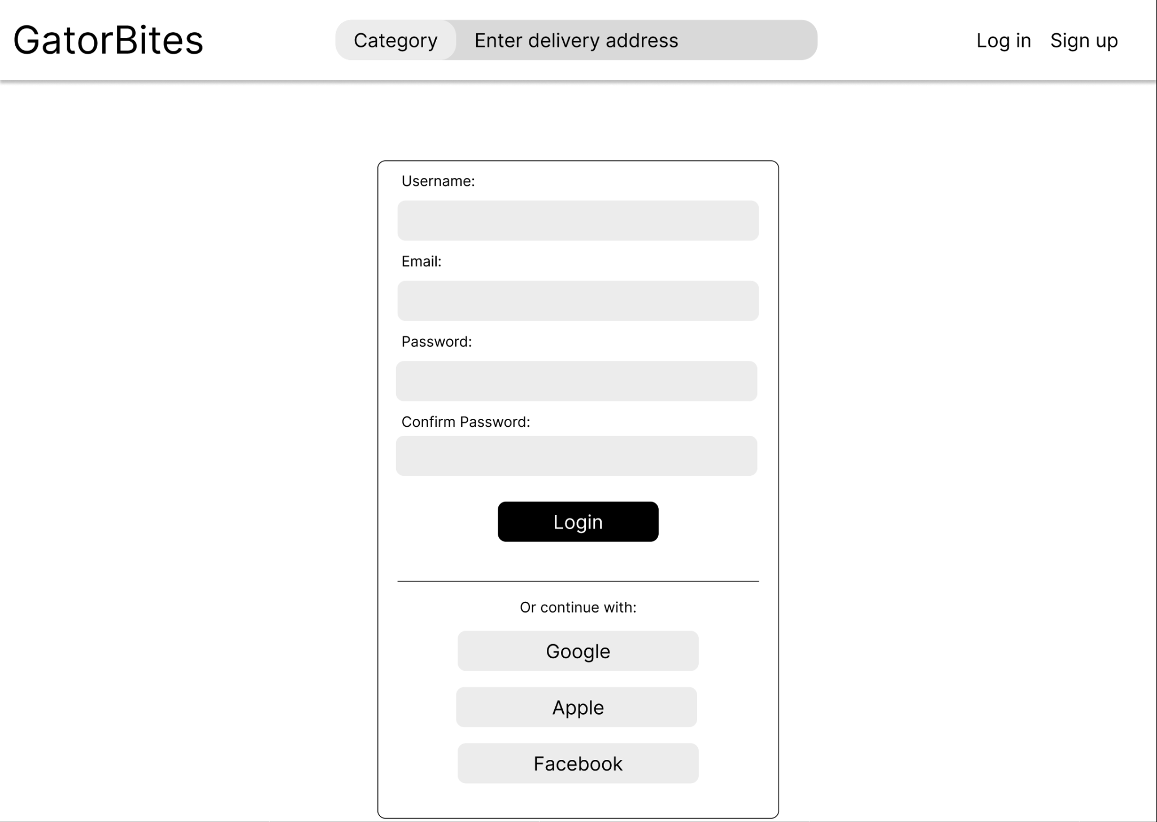

**(f)**

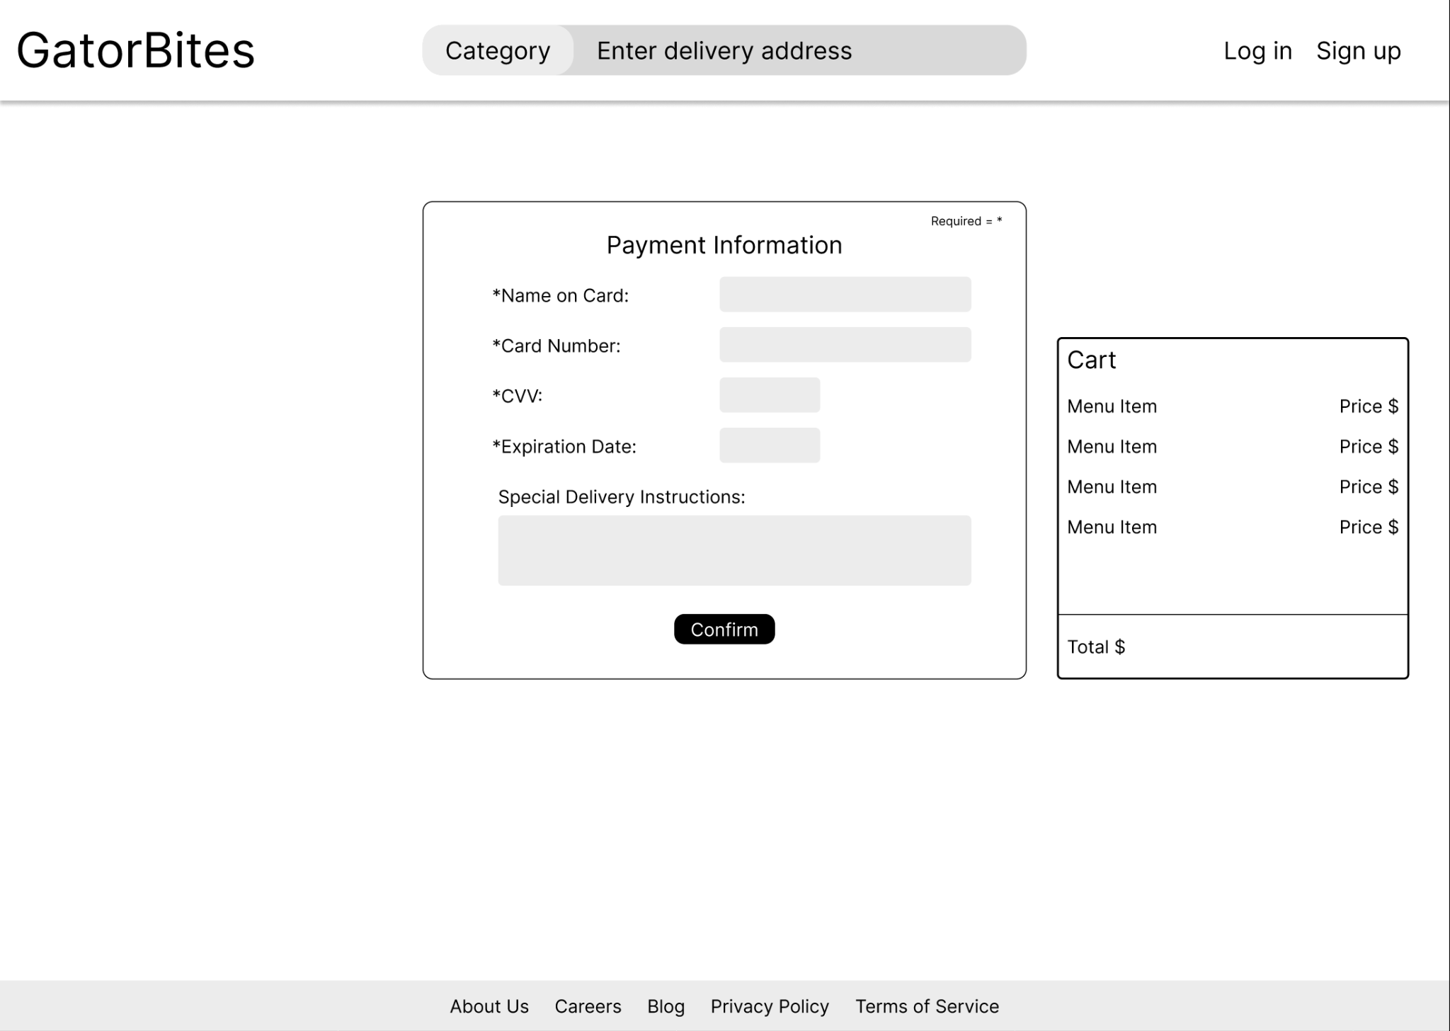

**Logging in to order with special instructions**

1. Michelle is currently working with a student group and doesn’t have time to grab food. She wants to be able to order from her office because she doesn’t want to leave the student group alone. She goes on her phone to order from GatorBites. She **logs** into her account and starts to browse restaurants that will deliver under 30 mins**(a)(b)(c)**. After deciding on one, she adds menu items to her cart. Not being able to decide what she wants, she **adds** and **removes** several menu items before checking out**(d)**. After she enters her building’s information, she is able to go back to helping the student group**(e)**. 25 minutes later, she is able to pick up her food from the delivery driver that is standing at the door of her office.

**(a)**



**(b)**



**(c)**



**(d)**

  
**(e)**



**Using homepage recommendations to order quickly**

1. Charlie is busy grading the midterms that most of his students will probably fail. He wants to be able to grab a healthier food option because that is what his doctor recommends but is not able to pick up in between classes due to his old age. He doesn’t have good vision and struggles with reading text on monitors so when he arrives on the GatorBites website, he clicks on whatever looks good**(a)**. He doesn’t have much time before his next class starts so he has to **order** quickly**(b)(c)**. After placing his order, he gets an estimated time of arrival so that he knows that the person entering his classroom late is not one of his students. He is able to get it delivered straight to his classroom.

**(a)**



**(b)**

  
**(c)**



**Accepting an order to deliver with route map**

1. Aaron is a delivery driver for GatorBites and he is waiting on campus near his bike for an order to come in. He logs into his account and checks driving tasks. This page contains the customer’s name and location, as well as the restaurant’s address and location. It will also have the food items that the customer ordered and the customer’s delivery instructions. Once Aaron gets the notification, he is able to bike to the restaurant to pick up the order and to bike back to the campus and deliver to his customer. He will also have a map of the campus so that he knows exactly where to go to deliver the order**(a)**.

**(a)**

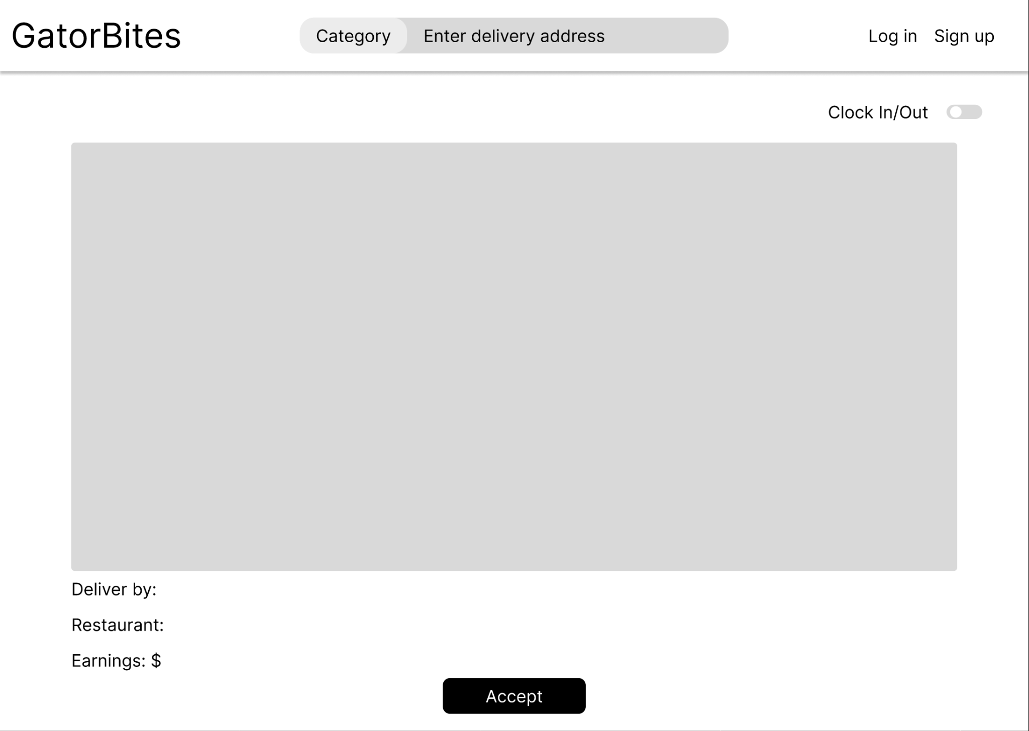

**Registering a restaurant**

1. Ceci is a restaurant manager and wants to get more customers ordering from her restaurant. She hears about a new delivery service called GatorBites from her friends who work in the restaurant industry. Curious, she wants to sign up her restaurant and wants to offer discounts for students to get more of them as customers**(a)(b)**. In order to sign up for her restaurant, she needs to be a registered user. After creating her account, she is able to create her own page. She is able to **fill** out her restaurant’s information like address, hours opened, how expensive her restaurant will be which will be represented by the amount of dollar signs. She is also able to add as many menu items as she wants, giving each menu item a name, price, description, and photo**(c)**. Descriptions and photos are optional fields. After she has finished **entering** all the information, she will get a confirmation email that her restaurant will be in the process of being approved and to wait 24 hours to be approved.

**(a)**



**(b)**

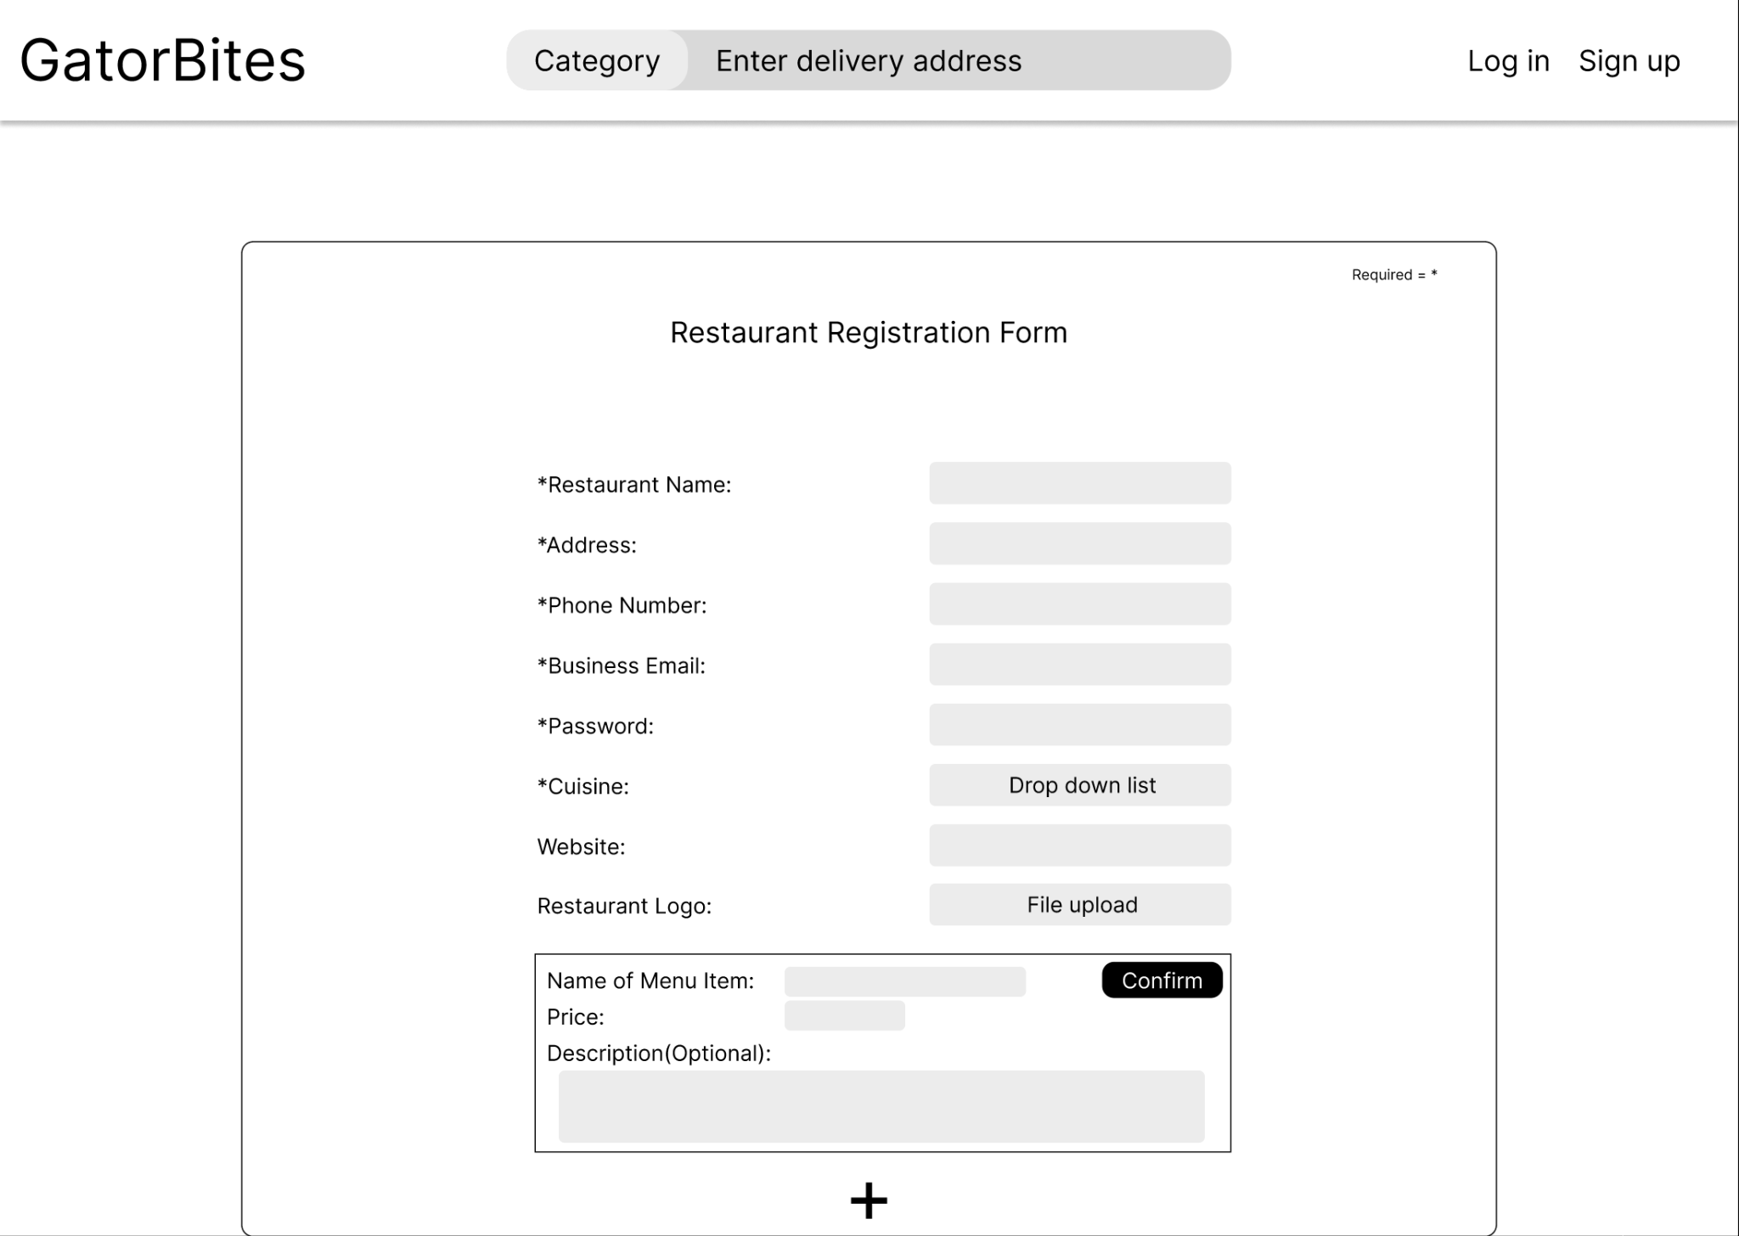

**(c)**

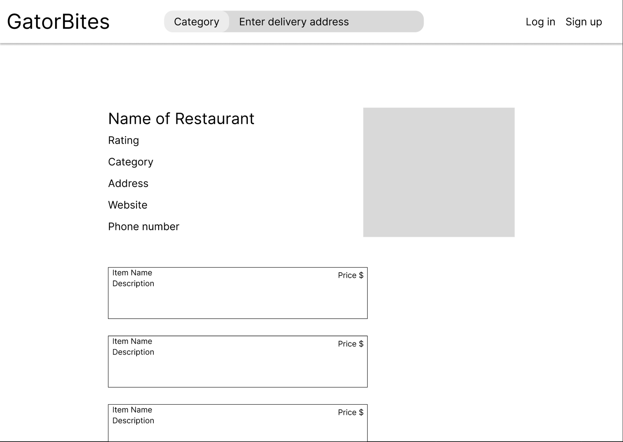

**Approving new drivers and restaurants**

1. William is an employee of GatorBites and is one of the admin in charge of pending restaurants and handling complaints. He will have **access** to information that only admin users can see**(a)**. William will be required to **view** pending restaurants for approval and click a button to approve them**(b)**. He will also be able to view complaints and **reports** from users. These reports can range from inappropriate language or images to a restaurant no longer taking orders.

**(a)**

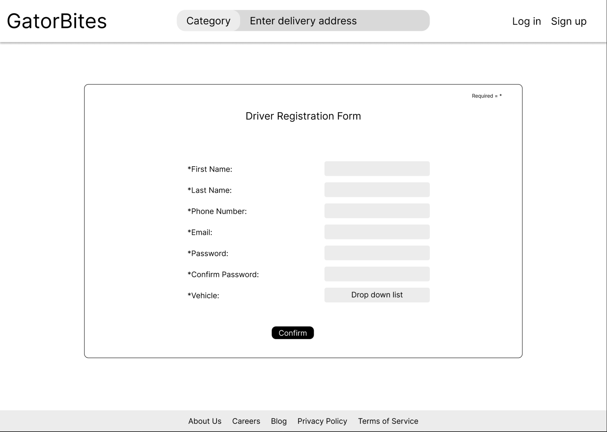

**(b)**



## **5 High level Architecture, Database Organization**

## **Main Database Schema/Organization**

User

user_id

email

password

name

phone

role

address

created_date

Admin

admin_id

username

password

Customer

customer_id

role_desc

password

Restaurant Owner

resaurant_owner_id

name

phone

password

Driver

driver_id

driver_name

password

make

model

license_plate

phone

rating

status

Restaurant

restaurant_id

restaurant_name

website

phone

address

city

state

zip_code

country

open

closed

Menu

menu_id

restaurant_id

diet_type

menu_desc

price

quantity

Menu Item

menu_Item_id

Restaurant_id

Price

Order

order_id

customer_id

menu_id

total_amount

payment_method

payment_status

delivery_address

status

Order Report

report_id

driver_id

order_id

customer_id

transaction_id

date

Payment

payment_id

order_id

payment_method

transaction_id

Notification

notification_id

user_id

message

notification_datetime

Delivery

delivery_id

order_id

driver_id

delivery_datetime

delivery_status

Promotion

promotion _id

restaurant_id

promo_code

promo_desc

discount

start_date

end_date

Complaint

complaint_id

userid

Complaint

Transaction

Transactionid

Orderid

Transaction_type

Discount_amount

Total_amount

Deliver_fee

## **Media Storage**

The decision on whether to keep images and video/audio in file systems or DB BLOBs will depend on the size and frequency of file uploads/downloads. For large files, it may be more efficient to store them in a file system and reference their file paths in the database. For smaller files, it may be more convenient to store them as BLOBs in the database. Special data format requirements will depend on the type of data being stored (e.g. image format, video codec, GPS format).

## **Search/Filter Architecture and Implementation**

The search algorithm will use SQL and the %LIKE operator to search for keywords in relevant DB terms (e.g. restaurant name, menu item description). The search items will be organized by relevance and displayed to the user in order of relevance. The search function will be coded as a SQL query that takes user input and returns relevant results. Additional search/filter options may include filtering by restaurant location or cuisine type.

## **Non Trivial Algorithm or Process**

No non-trivial algorithm has been planned or developed for the project.

## **Software Tools and Frameworks**

No additional tools or frameworks have been added.

## 

**6 Key Risks**

**Skill risks**

No one on the team is really familiar with the front-end besides the basics like css, handlebars, etc. We are more familiar with coding the back-end.

Resolution: We plan to resolve this by having our back-end team do their own research on our framework and be open to asking for help when needed.

**Schedule risks**

Our team has not run into any schedule risks with our product, because we have managed to effectively communicate what should be prioritized. We also stay ahead in our planning using monday.com so our team has ample time to work.

**Technical risks**

Currently, we are having issues with creating our databases on the cloud. This impacts our ability to link up the front-end with the back-end.

Resolution: Our back-end lead and team lead are working together to resolve this issue and it involves recreating our databases again.

**Teamwork risks**

Our team has not run into any teamwork risks because our team has managed to work together in a manner that is efficient, respectful, and effective and to be communicative if an issue would arise.

**Legal/Content risks**

Currently, we do not have any legal risks with our product. This is due to our team using software, sources, and materials that are open-source and available to the public.

**7 Project Management**

Our team has been actively using Monday.com as our go-to Project Management software. It is free for students and offers a similar experience to other PM softwares (Trello, Asana). We will continue to leverage the tools offered by Monday.com to organize and track the individual tasks we are assigned over the course of the semester. Aside from using Monday.com the team is engaged in more focused discussions in the team discord. This is where specific comments, questions, or concerns are dealt with in a timely manner. Personal messaging allows for team members to reach out to one another without involving unnecessary parties, increasing the context-specific collaboration, and allowing others to remain focused on their tasks without being bombarded with irrelevant notifications. Our PM software separates tasks into 5 categories – adding new ones as needed: This Week's tasks, Next Week's Tasks, Front End Tasks, Back End Tasks, Past Tasks.

A typical task is managed as follows:

1. Create the task with a descriptive name.

2. Assign to a team member.

3. Add a comment with instructions copied from the task relevant document.

4. Assign a soft due date allowing for last minute revisions.

5. Assign a hard due date for on-time submissions.

6. Maintain a “status” of the task: Done, Working on it, Stuck, or blank (not  
 started)

7. Track the status, ensuring team members are staying on track with due  
 dates.  
 8. Comment with feedback on initial submissions, allowing team members to  
 make revisions before final submission.

9. Give feedback on final submission so team member can gauge the quality  
 of their work and incorporate changes as needed in future tasks.

10. All team members have access to view others tasks/comments to  
 encourage collaborative efforts.